**RESTAURANT WEBSITE**

Project Report

Duration: 22nd – 27th December, 2025

Developed by: P. Manimegalai

# Executive Summary

# The Restaurant Website is a modern, responsive web-based platform designed to showcase restaurants, menus, and allow users to explore food options. The site provides a seamless user experience for browsing restaurant listings, viewing menu items, and checking prices. Admin controls allow easy content management, while the design ensures mobile and desktop responsiveness.

# Project Team

|  |  |
| --- | --- |
| **Role** | **Name** |
| Project Manager | Alagumari |
| Designer | Malathy |
| Developer | Manimegalai |
| Tester | Yogavarshini |

# Technology Stack

|  |  |
| --- | --- |
| **Frontend** | **Server** |
| HTML, CSS, JavaScript | GitHub Pages |

# Project Scope

# Restaurant Listings: Display multiple restaurants with images, ratings, and tags.

# Menu Showcase: Detailed menu cards with pricing and favorite options.

# Search Functionality: Users can search restaurants or menu items.

# User Interaction: Like/favorite dishes and interactive cards.

# Responsive Design: Works on desktop, tablet, and mobile devices.

# Admin Control: Admin can update menu images, prices, and restaurant info.

# Project Modules

|  |  |
| --- | --- |
|  |  |
|  |  |
|  |  |
|  |  |
|  |  |
|  |  |
|  |  |
|  |  |

# Key Highlights

# Fully Responsive Design: Optimized for desktops, tablets, and mobile devices.

# Interactive Restaurant & Menu Cards: Users can like/favorite items and click for detailed menus.

# Search Functionality: Fast search for restaurants and dishes with filtering options.

# Order Review Module: Users can adjust quantities, see total prices, and manage their order.

# Login & Registration System: Secure user authentication with email and password validation.

# Optimized Images: Lazy loading for faster page performance and smooth user experience.

# Modern Design: Attractive color palette (#B89C65, #F5EBDD) with Poppins font for readability.

# Admin Content Control: Easily update restaurants, menu items, pricing, and featured sections.

# Social Media Integration: Links to Facebook, Instagram, and Twitter for better connectivity.

# Deployment on GitHub Pages: Lightweight, fast-loading platform accessible online.

# Project Code

Below is an example snippet from the home.html structure:

<!DOCTYPE html>

<html lang="en">

<head>

  <meta charset="UTF-8">

  <title>BookMyTable</title>

  <meta name="viewport" content="width=device-width, initial-scale=1.0">

  <!-- Google Font -->

  <link href="https://fonts.googleapis.com/css2?family=Poppins:wght@300;400;500;600;700&display=swap" rel="stylesheet">

  <!-- Font Awesome Icons -->

  <link rel="stylesheet" href="https://cdnjs.cloudflare.com/ajax/libs/font-awesome/6.5.1/css/all.min.css" />

  <link rel="stylesheet" href="CSS/home.css">

</head>

<body>

  <!-- Top Menu -->

  <div class="top-nav">

    <ul>

      <li><a href="home.html">Home</a></li>

      <li><a href="reservation.html">Reservation</a></li>

      <li><a href="blogs.html">Blog</a></li>

      <li><a href="aboutus.html">About us</a></li>

      <li><a href="contact.html">Contact us</a></li>

      <li><a href="help.html">Help</a></li>

    </ul>

  </div>

  <!-- Header -->

  <div class="header">

    <div class="logo">

      <h1><span>Book</span>mytable</h1>

      <p><strong>Never wait for your meal</strong></p>

    </div>

    <div class="search-box">

      <input type="text" placeholder="Search">

      <i class="fa-solid fa-magnifying-glass"></i>

    </div>

    <button class="reg-btn" onclick="registerUser()">Register</button>

  </div>

  <!-- Hero -->

  <div class="hero">

    <h2>

      Book Table at your favourite restaurant and<br>

      get served instantly

    </h2>

  </div>

  <!-- Bottom Text -->

  <div class="bottom-text">

    <h3>Explore restaurent your city</h3>

    <!-- ================= CITY IMAGES ================= -->

    <section class="city-section">

      <div class="city-track">

        <div class="city-card" onclick="goToCity()">

          <img src="images/hydrabad.png">

          <h3>Hyderabad</h3>

        </div>

        <div class="city-card" onclick="goToCity()">

          <img src="images/bangalore.png">

          <h3>Bangalore</h3>

        </div>

        <div class="city-card" onclick="goToCity()">

          <img src="images/chennai.png">

          <h3>Chennai</h3>

        </div>

        <div class="city-card" onclick="goToCity()">

          <img src="images/mumbai.png">

          <h3>Mumbai</h3>

        </div>

    </section>

  </div>

  </div>

  <!-- HOW IT WORKS -->

  <section class="how-it-works">

    <h2>How it works</h2>

    <div class="steps">

      <div class="step">

        <i class="fa-solid fa-magnifying-glass"></i>

        <p>Search restaurant</p>

      </div>

      <div class="step">

        <i class="fa-regular fa-calendar"></i>

        <p>Select date/time</p>

      </div>

      <div class="step">

        <i class="fa-solid fa-chair"></i>

        <p>Reserve your table</p>

      </div>

      <div class="step">

        <i class="fa-solid fa-utensils"></i>

        <p>Get served instantly</p>

      </div>

    </div>

  </section>

  <!-- CUSTOMER REVIEWS -->

  <section class="customer-reviews">

    <h2>Customer Reviews</h2>

  </section>

  <!-- CUSTOMER REVIEW CARDS -->

  <section class="review-cards">

    <div class="review">

      <img src="images/amad.png" alt="Aman">

      <h4>Aman p.</h4>

      <div class="stars">★★★★★</div>

      <p>Great and excellent service</p>

    </div>

    <div class="review">

      <img src="images/david.png" alt="David">

      <h4>David.p</h4>

      <div class="stars">★★★★★</div>

      <p>Great and excellent service</p>

    </div>

    <div class="review">

      <img src="images/Gopi.png" alt="Gopi">

      <h4>Gopi.p</h4>

      <div class="stars">★★★★★</div>

      <p>Flexible Service</p>

    </div>

  </section>

  <!-- ================= MAP & SUBSCRIBE ================= -->

  <section class="bottom-section">

    <div class="map">

      <img src="images/map.png">

    </div>

    <div class="subscribe">

      <h1>Get offers in Your Inbox</h1>

      <div class="subscribe-box">

        <input type="email" placeholder="Enter your mail">

        <button>Subscribe</button>

      </div>

    </div>

  </section>

  <!-- FOOTER -->

  <footer class="footer">

    <div class="footer-top">

      <div class="footer-col">

        <h3>Company</h3>

        <p>About Us</p>

        <p>Contact Us</p>

        <p>Customer Reviews</p>

        <p>Add Your Restaurant</p>

      </div>

      <div class="footer-col">

        <h3>Policy Info</h3>

        <p>Terms & Conditions</p>

        <p>Cookies Policy</p>

        <p>Cancellation Policy</p>

        <p>Privacy Policy</p>

      </div>

      <div class="footer-col">

        <h3>Cities</h3>

        <p>Chennai</p>

        <p>Bangalore</p>

        <p>Hyderabad</p>

        <p>Mumbai</p>

      </div>

      <div class="footer-col">

        <h3>Help</h3>

        <p>Booking Status</p>

        <p>Add Restaurant</p>

      </div>

    </div>

    <hr>

    <div class="footer-middle">

      <p>Restaurant in Chennai</p>

      <p>Restaurant in Bangalore</p>

      <p>Restaurant in Hyderabad</p>

      <p>Restaurant in Pune</p>

      <p>Restaurant in Kolkata</p>

      <p>Restaurant in Mumbai</p>

    </div>

    <div class="footer-bottom">

      <div class="copyright">

        © 2025 Book My Table.Co.in. All rights reserved.

      </div>

      <div class="footer-contact">

        <p><i class="fa-solid fa-phone"></i> (123) 8940-985498</p>

        <p><i class="fa-solid fa-envelope"></i> info@bookmytable.com</p>

        <p><i class="fa-solid fa-location-dot"></i> Chennai 54375387</p>

      </div>

    </div>

    <div class="social-icons">

      <i class="fa-brands fa-facebook-f"></i>

      <i class="fa-brands fa-twitter"></i>

      <i class="fa-brands fa-instagram"></i>

    </div>

  </footer>

  <script>

    function registerUser() {

      window.location.href = "login.html";   // redirect page

    }

    function goHelp() {

      window.location.href = "contact.html";

    }

    function goToFav() {

      window.location.href = "whitelist.html";

    }

    function goToCity() {

      window.location.href = "cardcity.html";

    }

  </script>

</body>

</html>

# Project Screenshots

Sample screenshots from the Restaurant Website :

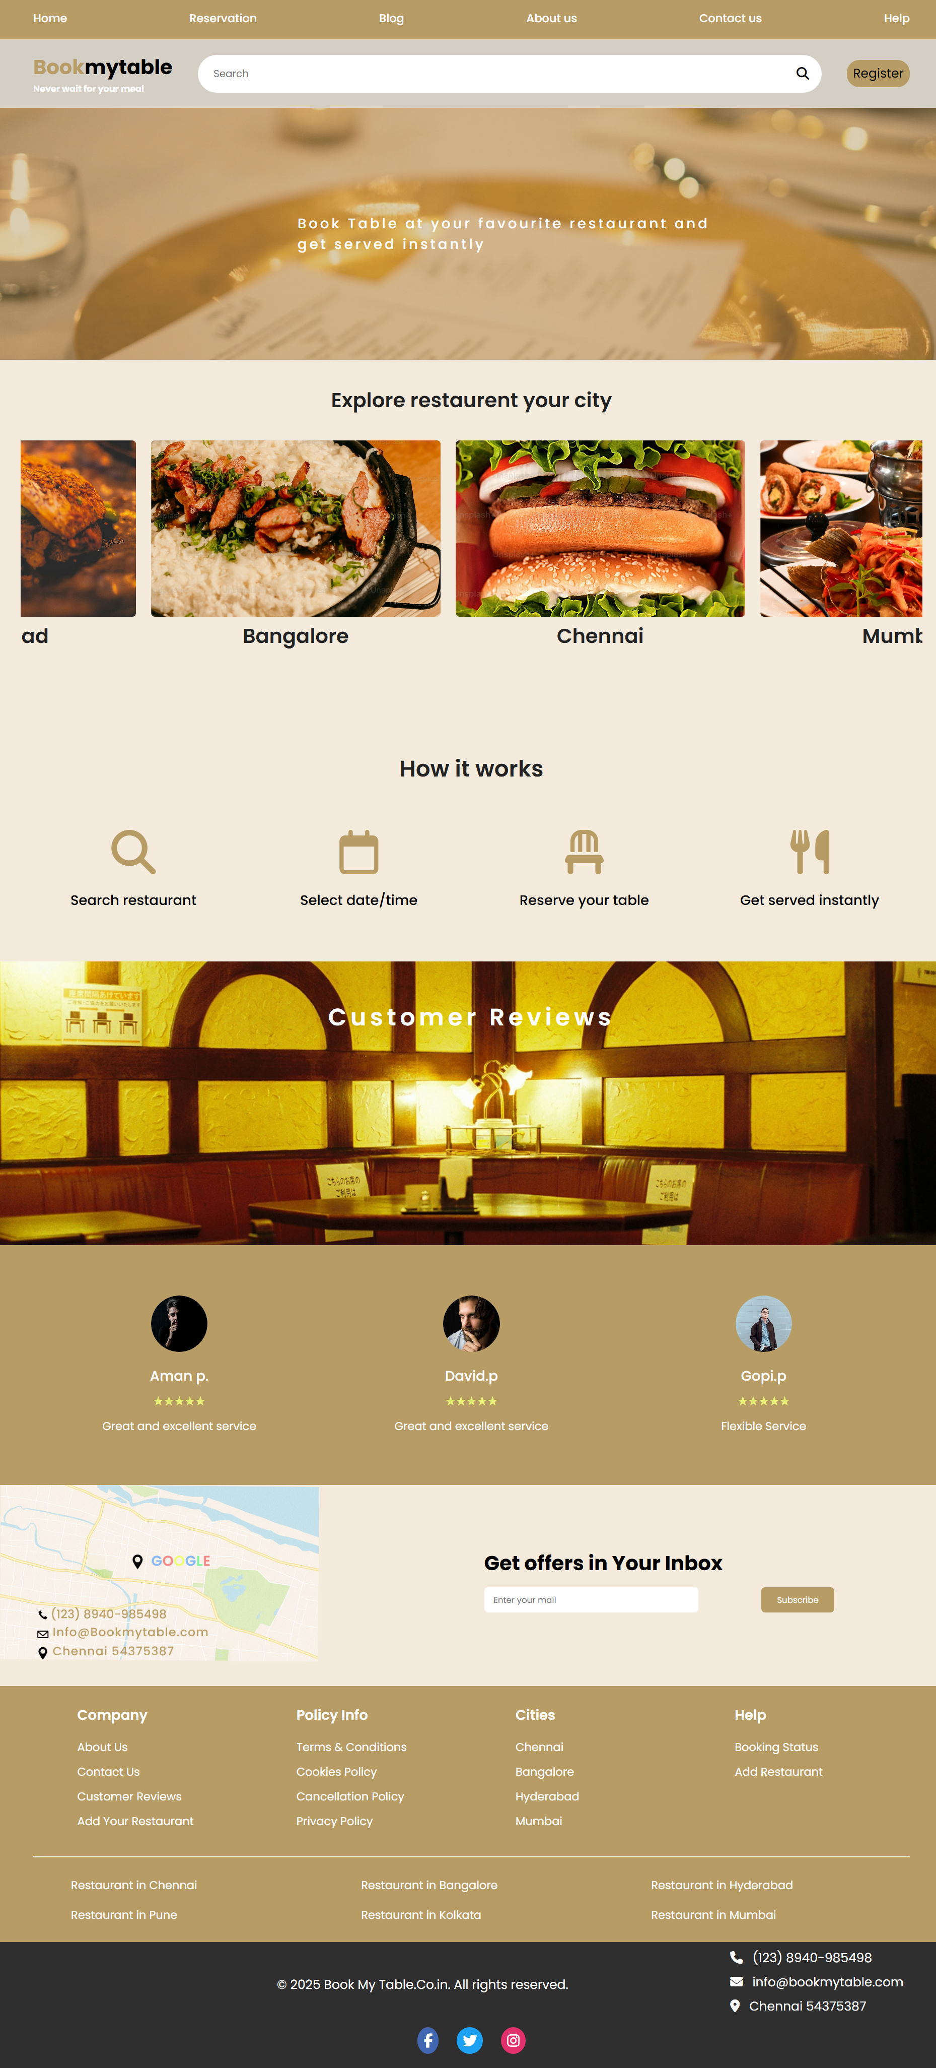

Figure: Home Page of Restaurant Website

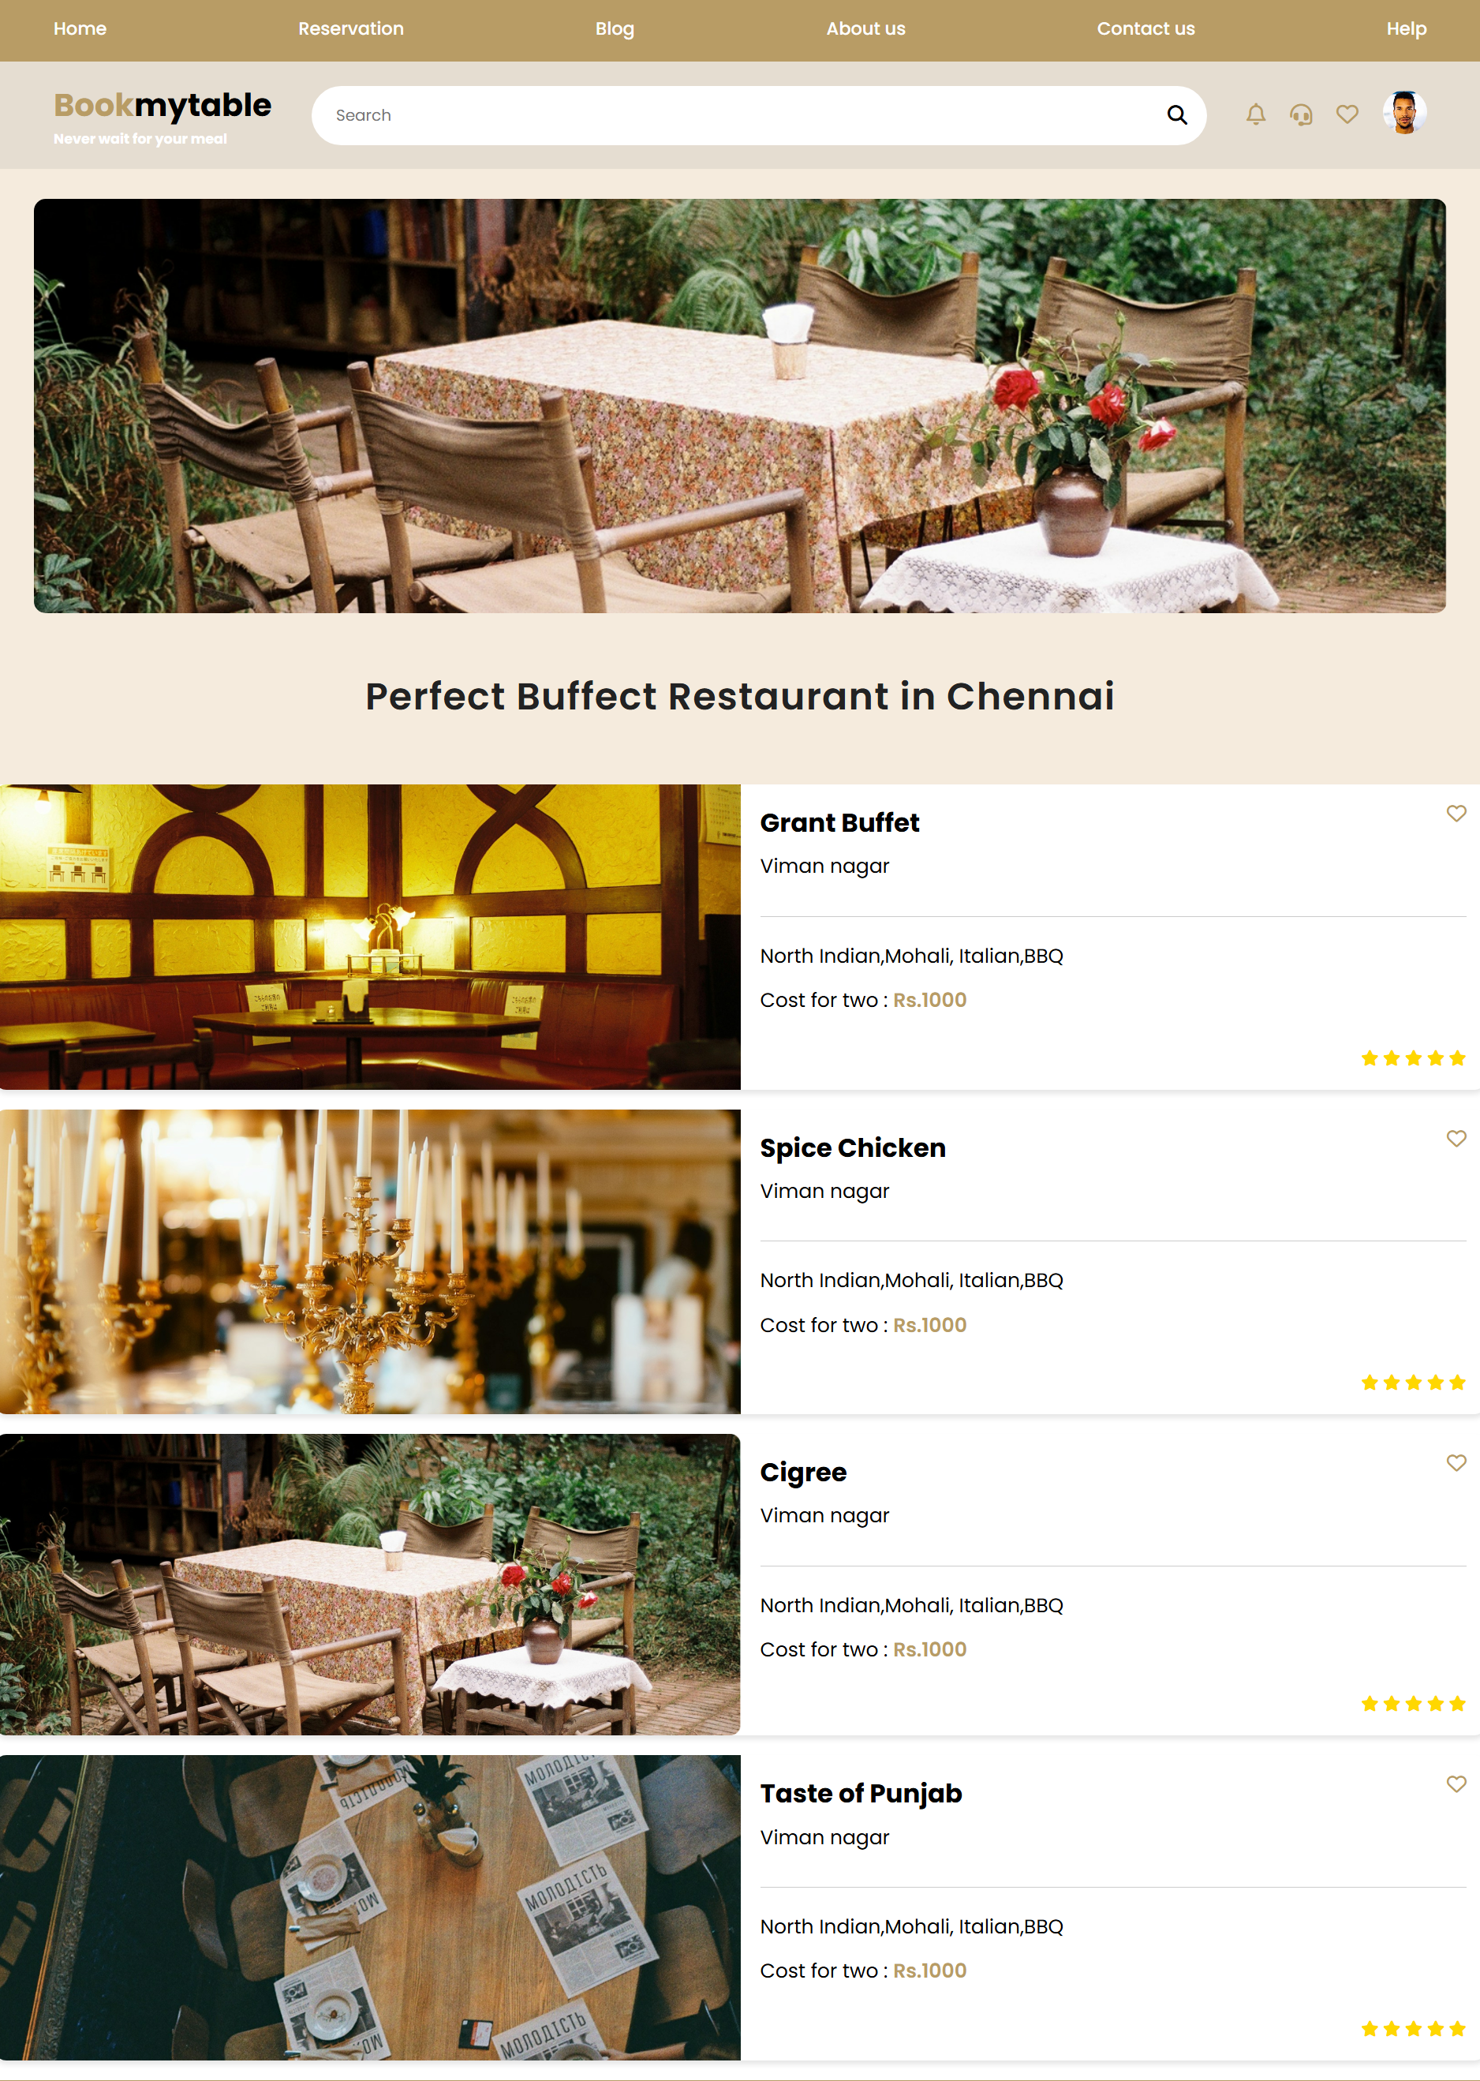

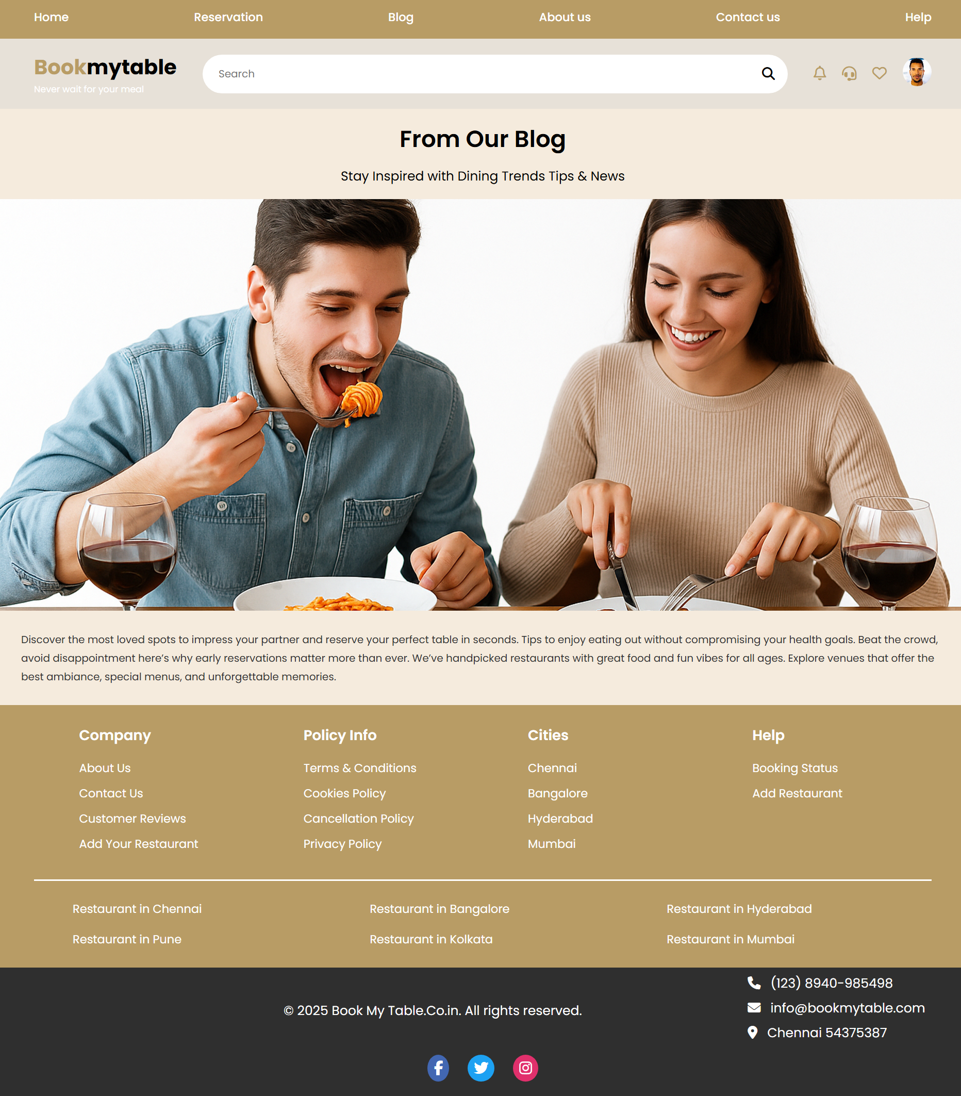

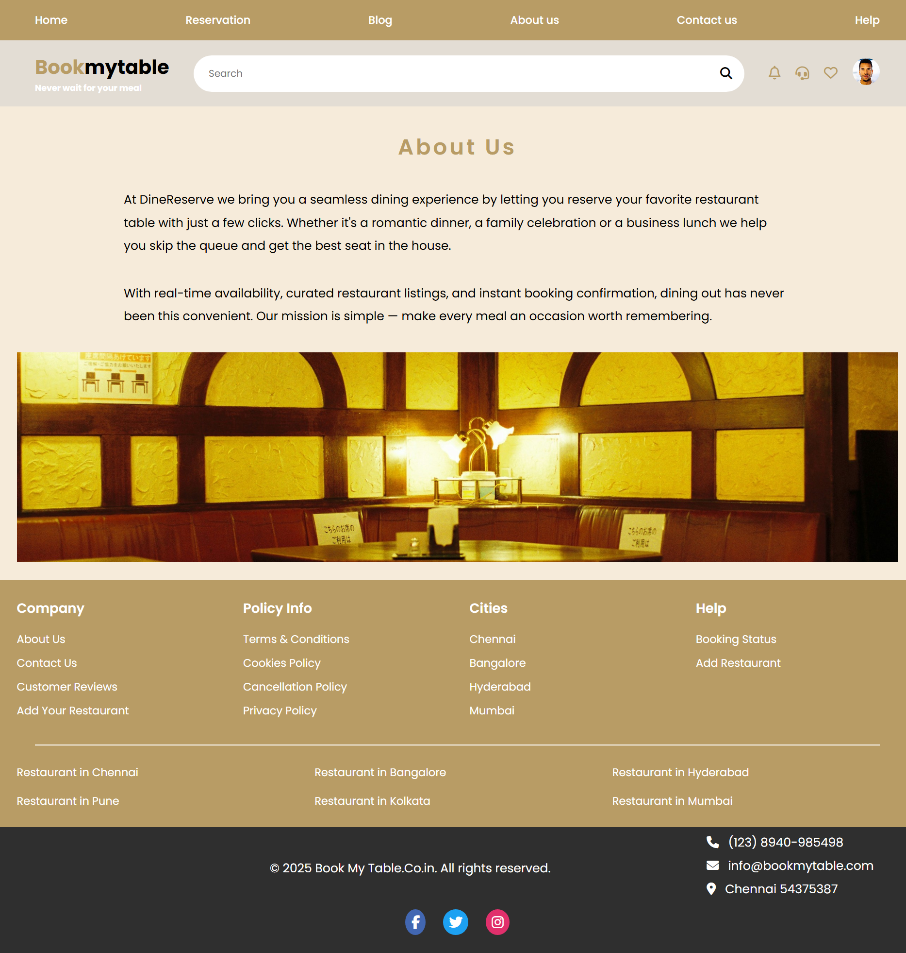  
  
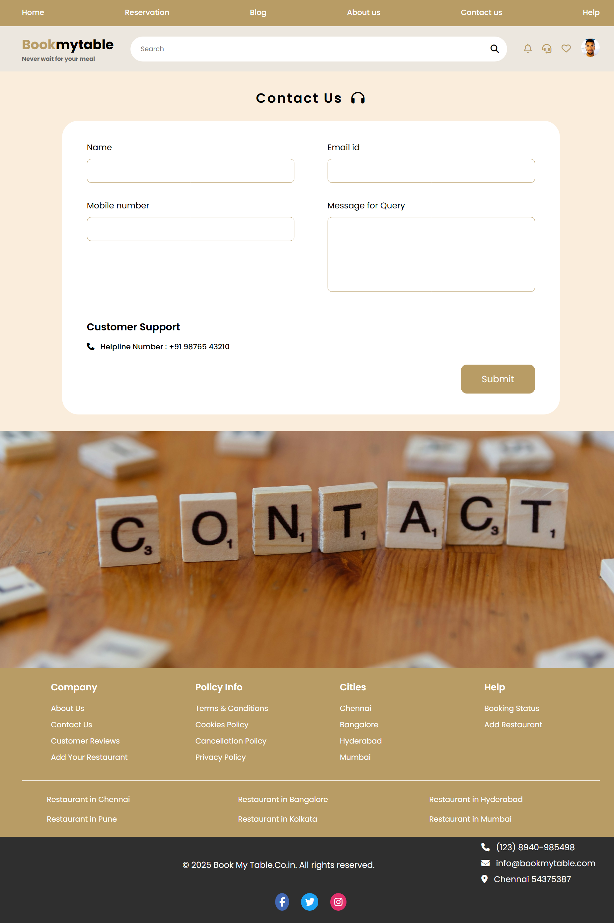  
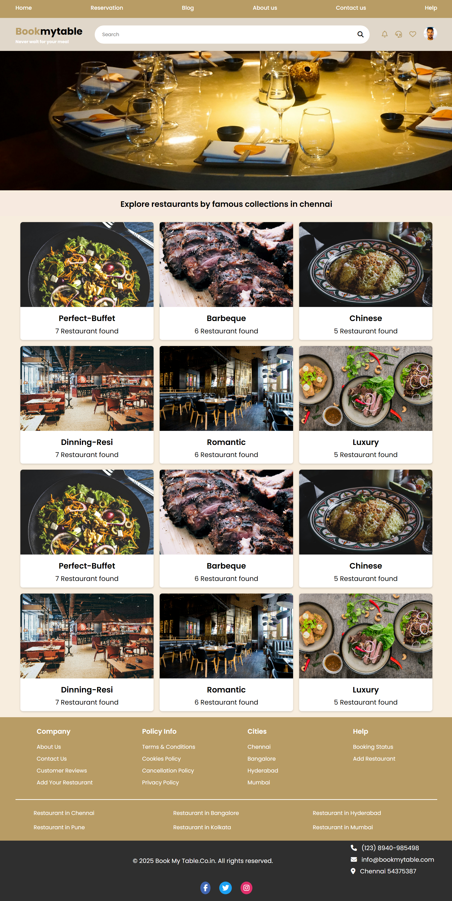

# Conclusion

The Restaurant Website provides a modern, interactive platform to explore restaurants and menu items efficiently. Its responsive design ensures excellent accessibility across devices. Hosting via GitHub Pages allows for fast loading times and easy sharing. The project demonstrates proficiency in **front-end web development**, effective use of **HTML, CSS, and JavaScript**, and the ability to deploy functional websites online.